UNIT V EXPERT SYSTEMS
Expert systems - Architecture of expert systems, Roles of expert systems - Knowledge Acquisition –Meta knowledge, Heuristics. Typical expert systems - MYCIN, DART, XOON, Expert systems shells.
1. Expert Systems:
  - An expert system is a set of programs that manipulate encoded knowledge to solve problems in a specialized domain that normally requires human expertise.
  - An expert system’s knowledge is obtained from expert sources and coded in a form suitable for the system to use in its inference or reasoning processes.
  - The expert knowledge must be obtained from specialists or other sources of expertise, such as texts, journal articles, and databases.
  - Once a sufficient body of expert knowledge has been acquired, it must be encoded in some form, loaded into a knowledge base, then tested, and refined continually throughout the life of the system.
Characteristic Features of Expert Systems:
- Expert systems use knowledge rather than data to control the solution process.
- The knowledge is encoded and maintained as an entity separate from the control program.
- Expert systems are capable of explaining how a particular conclusion was reached.
- Expert systems use symbolic representations for knowledge.
- Expert systems often reason with met knowledge.

Examples of Expert Systems:
- The first expert system to be completed was DENDRAL, developed at Stanford University in the late 1960.This system is capable of determining the structure of chemical compounds given a specification of the compound’s constituent elements and mass spectrometry data obtained from samples of the compound.
- MYCIN is an expert system which diagnoses infectious blood diseases and determines a recommended list of therapies for the patient.
- Expert system projects included PROSPECTOR, a system that assists geologists in the discovery of mineral deposits
2. Roles of Expert Systems:
A number of successful applications had been completed by then and they proved to be cost effective. Applications can now be found in almost all areas of business and government. They include such areas as
- Different types of medical diagnoses
- Diagnosis of complex electronic and electromechanical systems
- Diagnosis of software development projects
- Identification of chemical compound structures and chemical compounds.
- Location of faults in computer and communications systems
- Teaching students specialized tasks.
- Numerous applications related to space planning and exploration
- The design of very large scale integration (VLSI) systems.etc..

3.Applications of Expert Systems
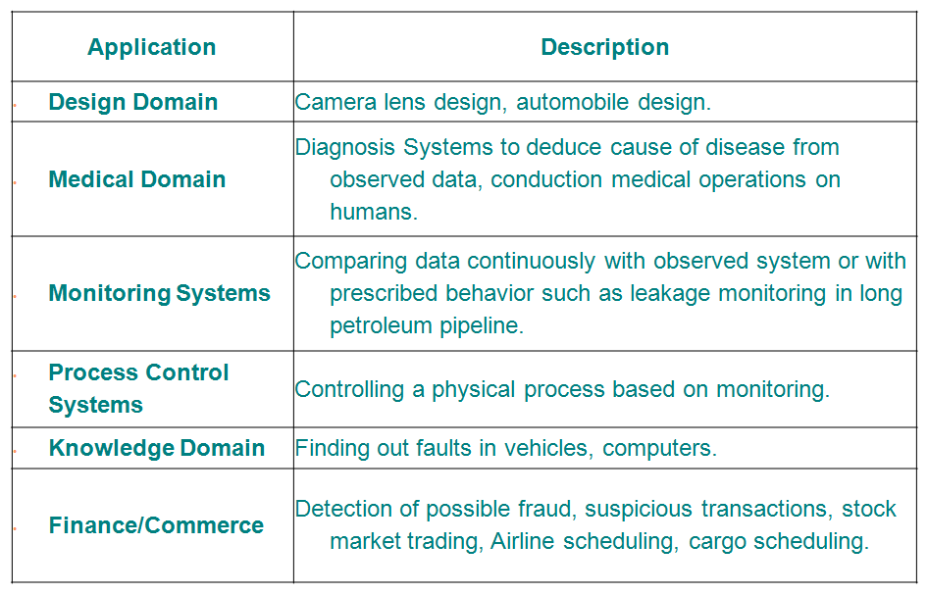
- Architecture of expert systems: The most common form of architecture used in expert and other types of knowledge based systems is the production system, also called the rule based system.
This type of system uses knowledge encoded in the form of production rules, that is, if ... then rules.
IF: Condition1 and Condition 2 and Condition 3
THEN: Take Action-4
IF: The temperature is greater than 200 degrees and
The water level is low
THEN: Open the safety valve

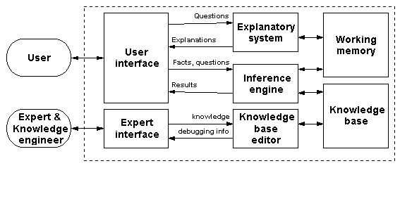
When the known facts support the conditions in the rule’s left side, the conclusion or action part of the rule is then accepted as known.
- Inference in production systems is accomplished by a process of chaining through the rules recursively, either in forward or backward direction, until a conclusion is reached or until failure occurs.
- The selection of rules used in the chaining process is determined by matching current facts against the domain knowledge or variables in rules and choosing among a candidate set of rules the ones that meet some given criteria, such as specificity.
User Interface:
User interface provides interaction between user and ES
It explains how the ES has arrived at a particular recommendation in the following forms
  - Natural language displayed on screen.
  - Verbal narrations in natural language.
  - Listing of rule numbers displayed on the screen.
Inference Engine:
- It consists of inference mechanism and control strategy.
- Inference means search through knowledge base and derive new knowledge.
- It involve formal reasoning involving matching and unification similar to the one performed by human expert to solve problems in a specific area of knowledge.
- There are mainly two types of control mechanism
a) Forward chaining
b) Backward chaining.
a) Forward Chaining
- Works from a set of facts and rules towards a set of conclusions
- It’s a Data driven approach in expert system knowledge inference engine.
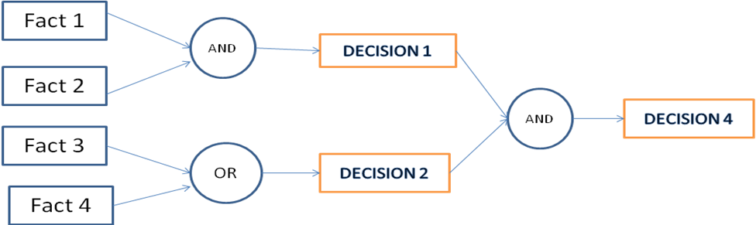
a)Backward Chaining
- From goals to create successive sub goals
- It’s a Goal driven approach in expert systems knowledge inference engine.
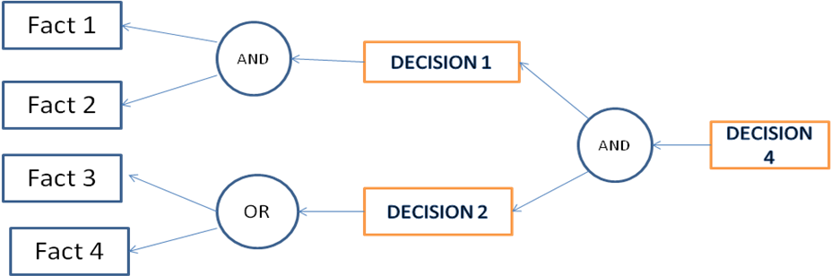
Explanation Systems & Knowledge acquisition:
In order for an expert system to be an effective tool, people must be able to interact with it easily. To facilitate this interaction, the expert system must have the following two capabilities in addition to the ability to perform its underlying task:
- Explain its reasoning. In many of the domains in which expert systems operate, people will not accept results unless they have been convinced of the accuracy of the reasoning process that produced those results.
- Acquire new knowledge and modifications of old knowledge. Since expert systems derive their power from the richness of the knowledge bases they exploit, it is extremely important that those knowledge bases be as complete and as accurate as possible.
TEIRESIAS was the first program to support explanation and knowledge acquisition. TEIRESIAS served as a front-end for the MYCIN expert system.

Expert Systems
An expert is a man who has made all the mistakes which can be made in a very narrow field.
-Niels Bohr (1885-1962) Danish physicist
Expert systems solve problems that are normally solved by human “experts”. To solve expert-level problems, expert systems need access to a substantial domain knowledge base, which must be built as efficiency as possible.
Representing And Using Domain Knowledge
Expert systems are complex. AI programs.The most widely used way of representing domain knowledge in expert systems is a set of production rules, which are often coupled with a frame system that defines the objects that occur in the rules.
Reasoning with the Knowledge
MYCIN used backward chaining to discover what organisms were present: then it used forward chaining to reason from the organisms to a treatment regime, RI, on the other hand, used forward chaining.
EXPERT SYSTEM SHELLS
The systems were constructed as a set of declarative representations (mostly rules) combined with an interpreter for those representations, it was possible to separate the interpreter from the domain-specific knowledge and thus to create a system that could be used to construct new expert systems by adding new knowledge corresponding to the new problem domain. The resulting interpreters are called shells.
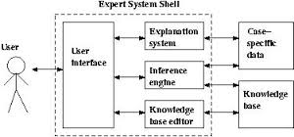
- One influential example of such a shell is EMYCIN (for Empty MYCIN) which was derived from MYCIN.
- These shells provide much greater flexibility in representing knowledge and in reasoning with it than MYCIN did. Then typically support rules, frames, truth maintenance systems, and a variety of other reasoning mechanisms.
- Expert systems cannot operate in a vacuum, any more than their human counterparts can. They need access to corporate databases, and access to them needs to be controlled just as it does for other systems.
- One of the important features that a shell must provide is an easy-to-use interface between an expert system that is written with the shell and a larger, probably more conventional, programming environment.
- In order for an expert system to be an effective tool, people must be able to interact with it easily. To facilitate this interaction, the expert system must have the following two capabilities in addition to the ability to perform its underlying task:
- Explain its reasoning. In many of the domains in which expert systems operate, people will not accept results unless they have been convinced of the accuracy of the reasoning process that produced those results.
- Acquire new knowledge and modifications of old knowledge. Since expert systems derive their power from the richness of the knowledge bases they exploit, it is extremely important that those knowledge bases be as complete and as accurate as possible.
- TEIRESIAS was the first program to support explanation and knowledge acquisition. TEIRESIAS served as a front-end for the MYCIN expert system.
- MYCIN attempts to solve its goal of recommending a therapy for a particular patient by first finding the cause of the patient’s illness. It uses its production rules to reason backward from goals to clinical observations. To solve the top-level diagnostic goal, it looks for rules whose right sides suggest diseases.
- The first question that the user asks is a “WHY” question, which is assumed to mean “Why do you need to know that?”
- Particularly for clinical tests that are either expensive or dangerous, it is important for the doctor to be convinced that the information is really needed before ordering the test. (Requests for sensitive or confidential information present similar difficulties).
- When TEIRESIAS provides the answer to the second of these questions and tells the user what it already believes, the user may want to know the basis for those beliefs. The user can ask this with a “HOW” question, which TEIRESIAS will interpret as “How did you know that?” This question also can be answered by looking at the goal tree and chaining backward from the stated fact to the evidence that allowed a rule that determined the fact to fire.
- SALT is a knowledge acquisition program used to build expert systems that design artifacts through a propose-and –revise strategy. SALT is capable of answering questions like WHY-NOT (“why didn’t you assign value x to this parameter?”) and WHAT-IF (“what would happen if you did?”).
KNOWLEDGE ACQUISITION
A knowledge engineer interviews a domain expert to elucidate expert knowledge, which is then translated into rules. After the initial system is built, it must be iteratively refined until it approximates expert-level performance.
There are many programs that interact with domain experts to extract expert knowledge efficiently. These programs provide support for the following activities:
- Entering knowledge
- Maintaining knowledge base consistency
- Ensuring knowledge base completeness
The most useful knowledge acquisition programs are those that are restricted to a particular problem-solving paradigm, e.g., diagnosis or design.
For example, if the paradigm is diagnosis, then the program can structure its knowledge base around symptoms, hypotheses, and causes. It can identify symptoms for which the expert has not yet provided causes.
Since one symptom may have multiple causes, the program can ask for knowledge about how to decide when one hypothesis is better than another.
An expert system produced by MOLE accepts input data, comes up with a set of candidate explanations or classifications that cover the data, and then uses differentiating knowledge to determine which one is best.
MOLE interacts with a domain expert to produce a knowledge base that a system called MOLE-p (for MOLE-performance) uses to solve problems.
The acquisition proceeds through several steps:
- Initial knowledge base construction. MOLE asks the expert to list common symptoms or complaints that might require diagnosis. For each symptom, MOLE prompts for a list of possible explanations. MOLE then iteratively seeks out higher-level explanations until it comes up with a set of ultimate causes.
- The expert provides covering knowledge, that is, the knowledge that a hypothesized event might be the cause of a certain symptom. MOLE then tries to infer anticipatory knowledge, which says that if the hypothesized event does occur, then the symptom will definitely appear. This knowledge allows the system to rule out certain hypotheses on the basis that specific symptoms are absent.
- Refinement of the knowledge base, MOLE now tries to identify the weaknesses of the knowledge base. One approach is to find holes and prompt the expert to fill them.
For example, suppose we have a patient with symptoms A and B. Further suppose that symptom A could be caused by events X and Y, and that symptom B can be caused by Y and Z. MOLE-p might conclude Y, since it explains both A and B. if the expert indicates that this decision was incorrect, then MOLE will ask what evidence should be used to prefer X and/or Z over Y.
MOLE has been used to build systems that diagnose problems with car engines, problems in steel-rolling mills, and inefficiencies in coal-burning power plants.
One problem - solving method useful for design tasks is called propose-and-revise.
Propose-and-revise systems build up solutions incrementally. First, the system proposes an extension to the current design. Then it checks whether the extension violates any global or local constraints.
There are three kinds of links: contributes-to, constraints, and suggests-revision-of.
- Associated with the first type of link are procedures that allow SALT to generate a value for one parameter based on the value of another.
- The second type of link, constraints, rules out certain parameter values.
- The third link, suggests-revision-of, points to ways in which a constraint violation can be fixed.
SALT uses the following heuristics to guide the acquisition process:
- Every non input node in the network needs at least one contributes-to link coming into it. If inks are missing, the expert is prompted to fill them in.
- No contributes-to loops are allowed in the network. Without a value for at least one parameter in the loop, it is impossible to compute values for any parameter in that loop. If a loop exists, SALT tries to transform one of the contributes-to links into a constraints link.
- Constraining links should have suggests-revision-of links associated with them. These include constraints links that are created when dependency loops are broken.

MYCIN
Introduction:
- MYCIN was an expert system developed at Stanford to diagnose and recommend treatment for certain blood infections.
- To do diagnosis properly need to do culture of the infecting organisms. This takes 48 hours and if doctors waited patient might be dead. So doctors have to come up with quick guess from available data.
- MYCIN was developed to explore how human experts make these rough guess based on partial information. There are lots of junior or non specialized doctors who sometimes have to make such rough guess.
- If there is an expert tool available to help them this might allow more effective treatment .
- In fact MYCIN was never actually used in practice not because of its weakness but it outperformed members of Stanford.
- MYCIN represented its knowledge as a set of IF-THEN rules with certainty factors.
IF the infection is primary –bacteremia
AND the site of the culture is one of the sterile sites
AND the suspected portal of entry is the gastrointestinal tract
THEN there is suggestive evidence(0.7) that infection is bacteroid

Organization of MYCIN system:
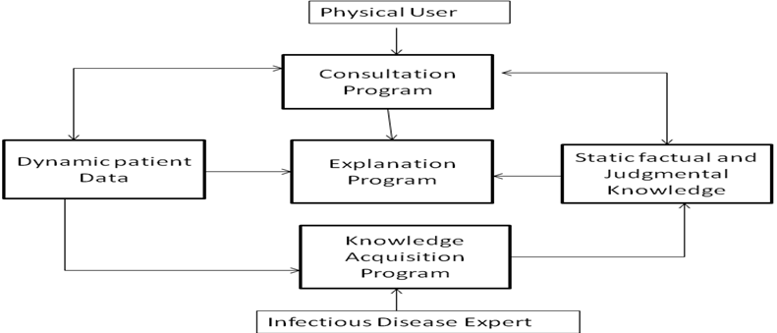

- MYCIN was written in LISP .The action part of the rule is a conclusion about the problem. This allowed great flexibility but removed some of the modularity of the rule-based system .MYCIN is a goal directed system using backward chaining strategy.

- One strategy is to first ask the user a number of preset questions , the system can then focus on more specific possible blood disorders and go into full backward chaining mode to try and prove each one.

- A dialogue with MYCIN has 3 stages :
First stage: Initial data about the case is gathered
Second stage: Directed questions are asked .Diagnosis is proposed
Third stage: Questions are asked to determine an appropriate treatment. Conclude with a treatment recommendation

- Problems in MYCIN:
1. Mixed domain knowledge
2. Problem solving knowledge
3. Screening conditions

- NEOMYCIN attempted to deal with these problems by having an explicit disease taxonomy to represents facts about different kinds of diseases. The basic problem solving strategy was to go down the disease tree from general classes to very specific ones.

Developments from MYCIN:
- EMYCIN-The first expert shell developed from MYCIN
- PUFF-A new expert system developed from EMYCIN for heart disorders
- NEOMYCIN-Developed for training doctors

DART
The consultant called DART was constructed using HMYCIN it is used for investigating automated diagnosis of machine faults.

Domain Knowledge
- A typical, large scale computer installation is composed numerous subsystems including CPUs, primary and secondary storage, peripherals and software.
- Each of these subsystem in turn consists of a richly connected set of both hardware and software components such as disk drives, controllers, memory modules and access methods.
- Each individual component has an associated set of diagnostic aids to test its own strategy.
- Identification of single or multiple faults from systematic manifestations remains a difficult task. Expert assistance is then required increasing both the time and cost required to repair the fault.
- DART reflects the expert’s ability to take a systematic viewpoint on problems.
- Example problems occurring in teleprocessing (TP) subsystem. This subsystem includes various network controllers, terminals, remote-job entry facilities, modems, and several software access methods.
- Two of the most frequent TP problems
(i)when a user is unable to log on to the system from a remote terminal.
(ii)When the system operator is unable to initialize the TP network.

DART Consultation
- During a DART consultation session, the field engineer focuses on a particular computer system that is experiencing a problem.
Many installation are composed of numerous CPUs that share
- peripherals. Within each system the user describes one or more problems by indicating a failure symptom
- Using this description the consultant makes an initial guess about which of the major subsystems might be involved in the fault.
- The user is then given the opportunity to select which of these subsystem are to be pursued.
- DART summarizes its findings and recommends additional tests and procedures to follow.
- The following diagram depicts the major steps of the diagnostic process outlined above.

DART Diagnostic Inference process

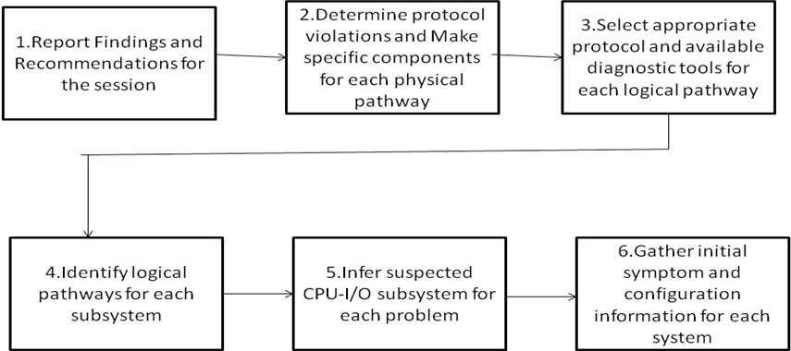

XCON
XCON is an expert system that expands and validates orders for DECVAX-11 computer systems and then configures the placement of components within the equipment cabinets.
- Customers purchasing DEC computers may select from a wide variety of components.
- The problem is that some orders then contain combinations of pieces that will not operate together, and some orders lack essential components.
- Before XCON was designed, technical editors examined the orders, identified nonfunctional combinations of components, and provided instructions for assembling the system.

- Since this process caused a bottleneck at DEC, and many attempts to automate it had failed, DEC was willing to try to solve this problem with a technology that was relatively unexplored in an industrial setting.
- John McDermott, then a research associate at Carnegie-Mellon University, felt that, DEC’s configuration problem could be solved using a rule-based expert system.
- McDermott and his associates performed the task definition, system
Design, and knowledge acquisition steps of expert system development at Carnegie-Mellon, although knowledge acquisition required much contact with DEC technical editors.
- The initial XCON was delivered to DEC in 1980. It, was a large system, containing about 750 rules, and even though it could configure many of the orders submitted to it, it required extension and refinement by DEC before it, could become the dependable system it is today.
- DEC learned that it could not, simply use the system as designed in the university and keeps it running. The systems knowledge had to be corrected and extended by people trained in knowledge acquisition and expert systems programming.
- A group was formed at DEC to assume responsibility for maintaining XCON. Unfortunately, its members were at a severe disadvantage.
- Most of them were DEC engineers who were not expert at AI. Even though some DEC engineers were familiar with AI, the maintenance group was not chosen for its AI expertise.
- Also, the system was written in OPS-4, a production system language developed at Carnegie-Mellon, with which no one in the group was familiar.
- After about a year and much aid from Carnegie-Mellon, the group was able to take over maintenance of XCON (which had grown to about 1,000 rules).This was a successful but difficult experience.
- DEC learned the hard way that maintaining an expert system requires
Specially trained personnel. In doing so, it trained some of those personnel. Today, XCON has grown to 2,500 rules and is far superior to the system that was delivered in 1980.
- It configures orders for all VAX-11 computer systems manufactured in the United States, as well as some orders for other machines. It is continually modified and updated to accommodate new options.
- XCON has become an integral part of the manufacturing process, and this integration was achieved by a group of people who had no previous experience with developing expert systems.
- The only problem was the time required for them to learn how. Many people feel that the primary significance of the XCON experience is that AI techniques were used to solve real-world problems in an industrial setting.
- However, this is less significant than the fact that an industrial, rather
than an academic, user was able to successfully help implement and maintain an AI system.
- Finally, DEC learned that knowledge-based systems must be maintained by trained personnel.

After XCON:
19. Around 1982, after the successful development of several Academic expert systems and the commercial success of XCON, AI was widely publicized in the popular press.
20. The Japanese made AI the focus of their fifth-generation computing
Effort, and a number of American corporations became interested in developing expert systems. DEC was no exception; it entered a period of widespread expert systems activity.
21. One of the many systems developed at DEC during this period was XSEL, an expert system related to XCON. “SEL” stands for “seller’s assistant”; XSEL aids sales representatives in tailoring a customer’s order to that customer’s particular needs.
22. It then delivers the order, along with the customer specific constraints it has gathered, to XCON for configuration.
23. XSEL’s history parallels that of XCON. Steps 1 to 3 of system development were done at Carnegie-Mellon, and the system was then delivered to DEC. Again, employees had to be trained in expert, system maintenance, because the XCON maintainers did not have enough time to maintain a second system.
24. This experience made DEC realize that it needed to establish a formal training program (which is described below). Other projects were XSITE, a system that helps prepare a customer’s site for the installation of a purchased processor, and efforts in VLSI design, hardware fault diagnosis, educational services, and office automation.
25. This research was performed by many different groups working independently, but there were some fairly coordinated efforts as well.
26. One group was formed in an explicit effort to decrease DEC’s dependence on university researchers.
27. This group, known as the Knowledge Engineering Advanced Group,
Was an offshoot of the XCON group; it consisted of four AI professionals. 28. The group’s function was to contract with other groups within DEC to carry out steps 2 through 4 of those groups’ expert system projects.
29. The Knowledge Engineering Advanced Development Group was given initial two-year funding with the intent that it become financially
Self-supporting after that time.
30. The Knowledge Engineering Advanced Development Group created two successful systems, one to aid in VLSI design, the other in hardware fault diagnosis.
31. More importantly, this was a formal attempt by DEC to increase the extent of technology transfer. While techniques were developed during the XCON and XSEL projects to facilitate the minimal transfer required for system maintenance and support, the Knowledge Engineering Advanced Development Group attempted to provide the expertise for the initial stages of expert system development.
32. This required an explicit corporate commitment to developing expert systems technology.
33. Even though XCON was a success, trained personnel were available to maintain expert systems, and new systems were being successfully initiated and completed in-house, the lack of a focus of activity became a critical problem at DEC.
34. First, few highly trained AI researchers were available, and since several groups within DEC were competing for them, no one group could secure a large number of qualified personnel.
35. Second, there was no large group of AI researchers working in one location. There was no way to coordinate the activities of the various research groups so that, for instance, they could agree on a common set of tools.
36. Furthermore, most of the AI professionals were accustomed to working in an environment providing sophisticated and powerful computing equipment and other AI researchers with whom they could share ideas.
37. Without a critical number of people in one location, that environment was difficult for DEC to provide.
38. Another problem was resource allocation. There was no central authority to decide which projects should be done and to allocate funding.
39. As I mentioned earlier, the method chosen for the Knowledge Engineering Advanced Development Group was to obtain funding from other groups within DEC, which meant that its choice of projects depended on the budgets of those groups.
40. This arrangement favored short-term projects with quick results, instead of longer-term development efforts that could build a foundation for a wider class of applications.
41. It was felt that an effective AI research group should have the freedom to choose projects without undue reliance on the budgets of other groups. Eventually a number of people, of whom I was one, began an informal process of reorganizing AI activity at DEC to achieve the goals we felt were needed for the successful transfer of AI technology.
42. As a result of this process, an organization was established to make informed decisions about AI research at DEC and to provide a centralized working environment.
43. This organization, known as the AI Technology Center, includes three technical groups. Their activities are not restricted, but they can be categorized as the engineering applications and advanced development group, the manufacturing applications group, and the customer service applications group.
44. In addition, there is a marketing group that monitors the current AI market and the public’s perception of AI There is also a formal training program to ensure a supply of qualified AI engineers to maintain the systems DEC produces.
45.Finally, there is a coordination committee to make major decisions and to direct the course of AI activity at DEC.
46. DEC’s artificial intelligence training program was established to avoid the maintenance problems DEC encountered when fielding XCON and XSEL.
47. Students are first given a fourteen-week introductory course in AI, which is taught by both DEC and university AI researchers.
48. They then enter 8 nine-month apprenticeship in building expert systems at either a university or a DEC AI group.
49. The aim of this program is not to produce AI researchers, but rather to provide a pool of people familiar with AI who can support the systems DEC develops.
50. I am a member of the engineering applications and advanced Development group, which is called the AI Technology Group.
51. It is currently staffed with six AI professionals having graduate degrees. We work mostly on engineering applications, but we also do advanced development work.
52. In addition to building expert systems, we are often called upon
to evaluate outside tools or DEC’s corporate strategies.

